Spring Boot Tutorial

Spring Boot is a Spring module that provides the RAD (Rapid Application Development) feature to the Spring framework.

What is Spring Boot
Spring Boot is a project that is built on the top of the Spring Framework. It provides an easier and faster way to set up, configure, and run both simple and web-based applications.
It is a Spring module that provides the RAD (Rapid Application Development) feature to the Spring Framework. It is used to create a stand-alone Spring-based application that you can just run because it needs minimal Spring configuration.
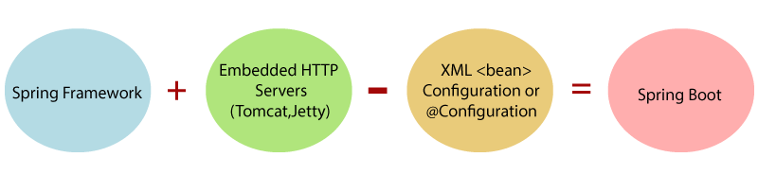
In short, Spring Boot is the combination of Spring Framework and Embedded Servers.
In Spring Boot, there is no requirement for XML configuration (deployment descriptor). It uses convention over configuration software design paradigm that means it decreases the effort of the developer.
We can use Spring STS IDE or Spring Initializr to develop Spring Boot Java applications.

Why should we use Spring Boot Framework?
We should use Spring Boot Framework because:
- The dependency injection approach is used in Spring Boot.
- It contains powerful database transaction management capabilities.
- It simplifies integration with other Java frameworks like JPA/Hibernate ORM, Struts, etc.
- It reduces the cost and development time of the application.
Along with the Spring Boot Framework, many other Spring sister projects help to build applications addressing modern business needs. There are the following Spring sister projects are as follows:
- Spring Data: It simplifies data access from the relational and NoSQL databases.
- Spring Batch: It provides powerful batch processing.
- Spring Security: It is a security framework that provides robust security to applications.
- Spring Social: It supports integration with social networking like LinkedIn.
- Spring Integration: It is an implementation of Enterprise Integration Patterns. It facilitates integration with other enterprise applications using lightweight messaging and declarative adapters.

Advantages of Spring Boot
- It creates stand-alone Spring applications that can be started using Java -jar.
- It tests web applications easily with the help of different Embedded HTTP servers such as Tomcat, Jetty, etc. We don't need to deploy WAR files.
- It provides opinionated 'starter' POMs to simplify our Maven configuration.
- It provides production-ready features such as metrics, health checks, and externalized configuration.
- There is no requirement for XML configuration.
- It offers a CLI tool for developing and testing the Spring Boot application.
- It offers the number of plug-ins.
- It also minimizes writing multiple boilerplate codes (the code that has to be included in many places with little or no alteration), XML configuration, and annotations.
- It increases productivity and reduces development time.

Limitations of Spring Boot
Spring Boot can use dependencies that are not going to be used in the application. These dependencies increase the size of the application.

Goals of Spring Boot
The main goal of Spring Boot is to reduce development, unit test, and integration test time.
- Provides Opinionated Development approach
- Avoids defining more Annotation Configuration
- Avoids writing lots of import statements
- Avoids XML Configuration.

Spring Boot Features
Several features of Spring Boot are as follows:

1. Web Development
It is a well-suited Spring module for web application development. We can easily create a self-contained HTTP application that uses embedded servers like Tomcat, Jetty, or Undertow. We can use the spring-boot-starter-web module to start and run the application quickly.

2. SpringApplication
The SpringApplication is a class that provides a convenient way to bootstrap a Spring application. It can be started from the main method. We can call the application just by calling a static run() method.
- public static void main(String[] args)
- {
- SpringApplication.run(ClassName.class, args);
- }

Spring vs. Spring Boot vs. Spring MVC

What is Spring?
Spring Framework is one of the most popular frameworks for Java application development. Its main feature is Dependency Injection (DI) or Inversion of Control (IoC), which helps developers create loosely coupled applications. Spring is mainly used for developing enterprise-level Java applications.

What is Spring Boot?
Spring Boot is a module of the Spring Framework that makes application development faster and easier. It reduces boilerplate code and minimizes configuration work, allowing developers to quickly create stand-alone and production-ready Spring applications. Spring Boot is widely used for building RESTful web services and microservices.

What is Spring MVC?
Spring MVC is a web framework provided by the Spring Framework for developing web applications. It follows the Model-View-Controller (MVC) design pattern and helps manage web requests efficiently. Spring MVC is mainly used for creating HTTP-based web applications with organized and structured architecture.

Spring Boot Architecture
Spring Boot is a module of the Spring Framework that is used to create stand-alone and production-ready Spring applications with minimal configuration. It is built on top of the core Spring Framework and simplifies Java application development.
Spring Boot follows a layered architecture where each layer performs a specific task and communicates with the layer above or below it.

Layers of Spring Boot Architecture
The following are the main layers of Spring Boot Architecture:
- Presentation Layer
- Business Layer
- Persistence Layer
- Database Layer
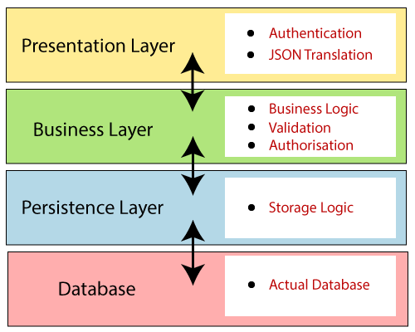

1. Presentation Layer
The Presentation Layer handles client-side requests and responses. It processes HTTP requests, converts JSON data into objects, and sends the request to the business layer. This layer mainly contains the frontend or view-related components.

2. Business Layer
The Business Layer contains the main business logic of the application. It performs operations such as validation, authorization, and processing of data. This layer mainly consists of service classes.

3. Persistence Layer
The Persistence Layer manages the database-related logic of the application. It converts business objects into database records and retrieves data from the database when required.

4. Database Layer
The Database Layer is responsible for storing and managing application data. CRUD operations such as create, read, update, and delete are performed in this layer./p>

Spring Boot Flow Architecture
Spring Boot uses different Spring modules such as Spring MVC, Spring Data JPA, and others to develop web applications. The architecture of Spring Boot is similar to Spring MVC, but Spring Boot reduces configuration work and removes the need to create separate DAO and DAOImpl classes manually in many cases.
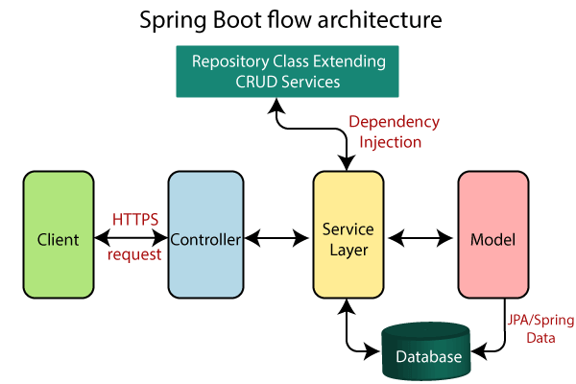

Flow of Spring Boot Architecture

Spring Boot Architecture
Last Updated : 18 May 2026
Spring Boot is a module of the Spring Framework that is used to create stand-alone and production-ready Spring applications with minimal configuration. It is built on top of the core Spring Framework and simplifies Java application development.
Spring Boot follows a layered architecture where each layer performs a specific task and communicates with the layer above or below it.

Layers of Spring Boot Architecture
The following are the main layers of Spring Boot Architecture:
- Presentation Layer
- Business Layer
- Persistence Layer
- Database Layer

1. Presentation Layer
The Presentation Layer handles client-side requests and responses. It processes HTTP requests, converts JSON data into objects, and sends the request to the business layer. This layer mainly contains the frontend or view-related components.

2. Business Layer
The Business Layer contains the main business logic of the application. It performs operations such as validation, authorization, and processing of data. This layer mainly consists of service classes.

3. Persistence Layer
The Persistence Layer manages the database-related logic of the application. It converts business objects into database records and retrieves data from the database when required.

4. Database Layer
The Database Layer is responsible for storing and managing application data. CRUD operations such as create, read, update, and delete are performed in this layer./p>

Spring Boot Flow Architecture
Spring Boot uses different Spring modules such as Spring MVC, Spring Data JPA, and others to develop web applications. The architecture of Spring Boot is similar to Spring MVC, but Spring Boot reduces configuration work and removes the need to create separate DAO and DAOImpl classes manually in many cases.
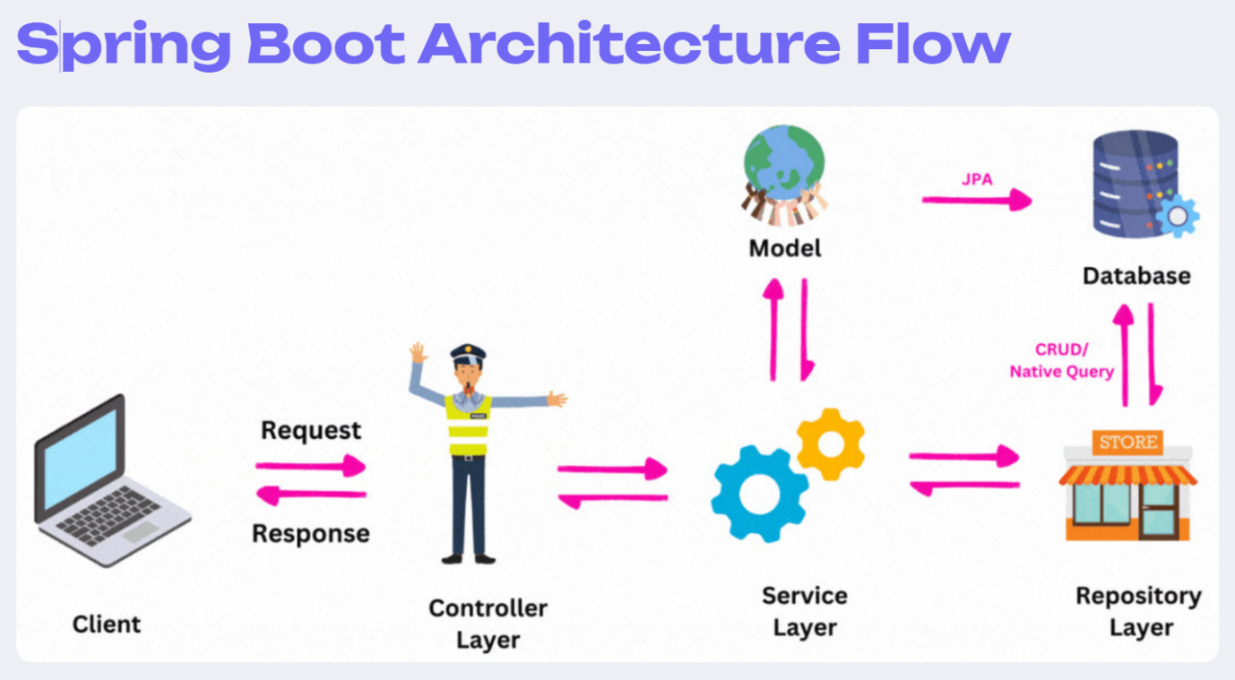

Flow of Spring Boot Architecture
The following steps explain the working flow of Spring Boot Architecture:
- The client sends an HTTP request such as GET, POST, PUT, or DELETE.
- The request goes to the Controller class, where the request is mapped and handled.
- The Controller calls the Service Layer if business logic is required.
- The Service Layer performs all business-related operations and processes the data.
- The processed data is passed to the Persistence Layer, where JPA interacts with the database.
- The Database Layer performs CRUD operations such as create, read, update, and delete.
- Finally, the response is returned to the user in the form of a web page, JSON response, or API result.

The following steps explain the working flow of Spring Boot Architecture:
- The client sends an HTTP request such as GET, POST, PUT, or DELETE.
- The request goes to the Controller class, where the request is mapped and handled.
- The Controller calls the Service Layer if business logic is required.
- The Service Layer performs all business-related operations and processes the data.
- The processed data is passed to the Persistence Layer, where JPA interacts with the database.
- The Database Layer performs CRUD operations such as create, read, update, and delete.
- Finally, the response is returned to the user in the form of a web page, JSON response, or API result.

